Haaga Cleaning Robot
Guide Manual

Ver. 2
Written by Jeongmin 2016/4/26
Table of contents
1. Overview - - - - - - - - - - - - - - - - - - - - - - - - - - - - - - - - - - - 3
2. Acknowledgement - - - - - - - - - - - - - - - - - - - - - - - - - - - - - 3
3. Haaga System - - - - - - - - - - - - - - - - - - - - - - - - - - - - - - - 4
3.1 Basic components - - - - - - - - - - - - - - - - - - - - - - - - - - - - - - - - - - - - - - - - - 4
3.2 System architecture - - - - - - - - - - - - - - - - - - - - - - - - - - - - - - - - - - - - - - - 5
3.3 Hardware specification- - - - - - - - - - - - - - - - - - - - - - - - - - - - - - - - - - - - - - 6
4. ArduHaaga firmware - - - - - - - - - - - - - - - - - - - - - - - - - - - 19
4.1 Compile and Upload - - - - - - - - - - - - - - - - - - - - - - - - - - - - - - - - - - - - - - 19
4.2 Source - - - - - - - - - - - - - - - - - - - - - - - - - - - - - - - - - - - - - - - - - - - - - - - - 20
5. Applications - - - - - - - - - - - - - - - - - - - - - - - - - - - - - - - - - 26
5.1 Haaga Controller - - - - - - - - - - - - - - - - - - - - - - - - - - - - - - - - - - - - - - - - - 26
5.2 Fisheye Camera Calibration - - - - - - - - - - - - - - - - - - - - - - - - - - - - - - - - - 29
6. Tutorials - - - - - - - - - - - - - - - - - - - - - - - - - - - - - - - - - - - - 34
6.1 AroundViewer - - - - - - - - - - - - - - - - - - - - - - - - - - - - - - - - - - - - - - - - - - - - 34
6.2 LineFollower - - - - - - - - - - - - - - - - - - - - - - - - - - - - - - - - - - - - - - - - - - - - 39
7. ROS - - - - - - - - - - - - - - - - - - - - - - - - - - - - - - - - - - - - - - - 44
7.1 rosserial - - - - - - - - - - - - - - - - - - - - - - - - - - - - - - - - - - - - - - - - - - - - - - - 44
7.2 Communication between Bluno and Jetson- - - - - - - - - - - - - - - - - - - - - - - 46
7.3 LineFollower with ROS - - - - - - - - - - - - - - - - - - - - - - - - - - - - - - - - - - - - 50
1. Overview
The autonomous Haaga cleaning robot has two front brushes and each brush rotates in opposite directions grabbing the debris directly in front of the sweeper while the brush roller on the bottom picks up all the fine particles.
This manual provides both the general and technical details you need to operate your Haaga cleaning robot and to begin developing robot hardware and software.
The default firmware is encoded. In order to change the robot algorithm, the firmware needs to be changed, compiled and reprogrammed as explained in this github.

2. Acknowledgement
The hardware design was originally based on the Haaga-697 sweeper.
Haaga cleaning robot now uses the Bluno mega 2560 board to control DC motors for autonomous driving, replacing hand-powered operation.

3. Haaga System

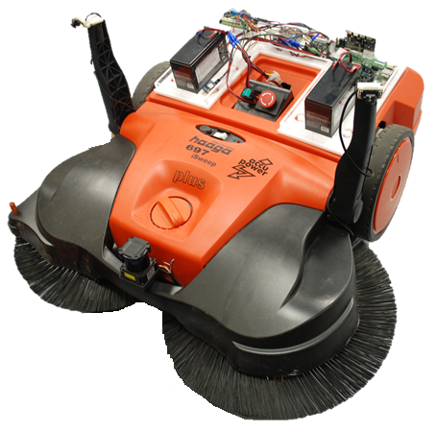
Figure 1. Hardware configuration
3.1 Basic components
- Haaga-697 (modified)
- Battery charger
- DC motor x2
- Encoder x2
- 12V Battery x3
- Fisheye camera x2
- Lidar
- Arduino board with Bluetooth module
- IMU sensor
- GPS sensor
- Single board computer
- Motor drive
- Emergency stop button
- Power switch

3.2 System architecture
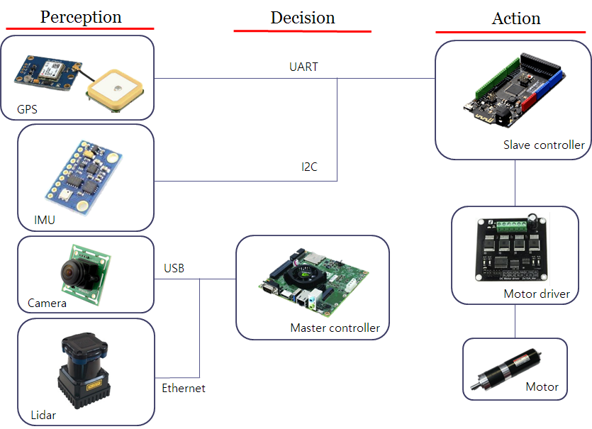
Figure 2. System architecture
There are two controllers for autonomous driving of cleaning robot. Master and slave controller are connected with serial port via micro USB. GPS and IMU sensor are connected to slave controller for localization, and Camera and Lidar are connected to master controller to recognize objects.

3.3 Hardware Specification
3.3.1 Slave Control Board

Bluno mega 2560 (Arduino+BLE)
- Microcontroller：ATmega2560
- Clock frequency: 16MHZ
- Working voltage：+5V
- External input voltage (recommended)：7 ~ 12V DC
- External input voltage (range)：6 ~ 20V DC
Digital I/O outputs: 54 (14 PWM outputs)
Analog inputs: 16
I/O current: 40mA
Flash capacity: 256KB (4k for bootloader)
Static storage capacity of SRAM: 8KB
Memory capacity of EEPROM: 4KB

Bluno Mega2560 inherits the numerous ports and the abundant resources of Mega series, and adds Bluetooth 4.0 wireless communication function. It has 54 digital I/O (input/output) ports (15 of which can be used as PWM output), 16 analog input and 4 UART (hardware serial ports), and uses 16 MHz imported crystal oscillators. The following figure shows Bluno mega controller with connected ports, which includes:
- Power: 12V Battery power
- Serial connection with Master controller
- 4 interrupted pin with Encoders
- 2 Digital input with GPS
- 2 Digital input with Gyro
- 4 Digital output with motor driver
where the numbering 1 means right and 2 means left. (motor1=right motor)
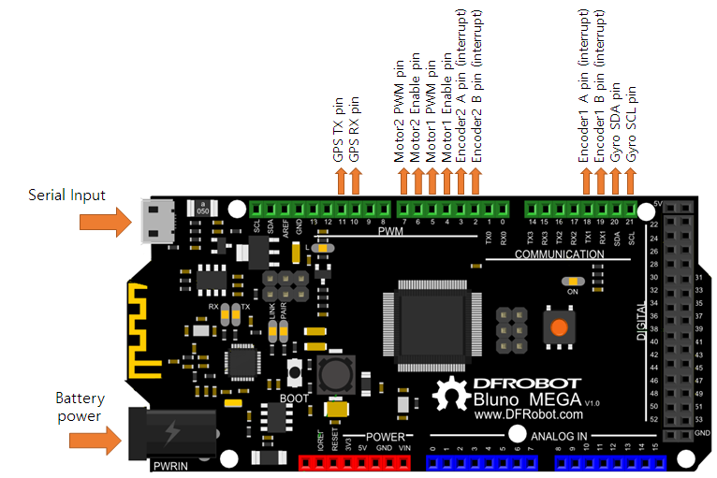
Figure 3. Bluno mega pin out
Bluno mega have the same serial port configuration, with only adding a serial port for Bluetooth 4.0 which uses Serial0 wireless passthrough. Because bluno mega has four serial ports, if you want to upload your code, use Serial2 or Serial3 ports (pin 14,15,16,17).

This board is also used to PID control of the DC motors via motor driver and acquiring GPS and IMU sensor’s data. The default loop frequency is 20Hz. By the commands through the serial port, you can change the PID gains and motor speed. The valid commands are as follow table. All the commands’ type is string and the commands should be end with ‘E’ character. And every loop, Bluno send the robot status that containing motor speed, encoder counts, GPS coordinates and heading via serial port. The type of output is also string and each value are divided by comma.

Table 1. Commands Lists
Input Commands | Description | Type
M+E | Mode change to Bluetooth | String
M-E | Mode change to Automatic | String
S+E | Increase motors acceleration | String
S-E | Decrease motors acceleration | String
P+E | Increase ‘P’ gain of Motor1 | String
P-E | Decrease ‘P’ gain of Motor1 | String
O+E | Increase ‘I’ gain of Motor1 | String
O-E | Decrease ‘I’ gain of Motor1 | String
I+E | Increase ‘D’ gain of Motor1 | String
I-E | Decrease ‘D’ gain of Motor1 | String
L+E | Increase ‘P’ gain of Motor2 | String
L-E | Decrease ‘P’ gain of Motor2 | String
K+E | Increase ‘I’’ gain of Motor2 | String
K-E | Decrease ‘I’ gain of Motor2 | String
J+E | Increase ‘D’ gain of Motor2 | String
J-E | Decrease ‘D’ gain of Motor2 | String
R[value]L[value]E | Set motor’s RPM. For example, R100L100E command means that setting the RPM of right motor and left motor to 100.  The maximum RPM value of the motor is 300 (-300 ~ 300). | String

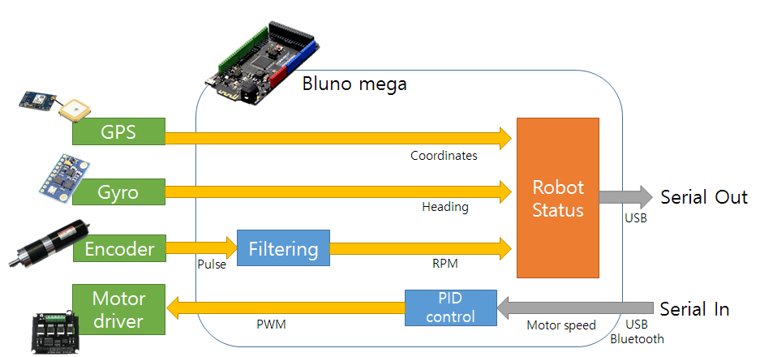
Figure 4. Flow Diagram of Slave Controller

3.3.2 GPS
Ublox neo 6m
- u-blox NEO-6M onboard, with high-gain active antenna
- IPX interface, for connecting different active antennas
- Chargeable backup battery, keeps the ephemeris data when power down, supports hot starts
- Onboard EEPROM for storing config information

Receiver type | 50 channels, GPS L1(1575.42Mhz) C/A code, SBAS:WAAS/EGNOS/MSAS
Horizontal position accuracy | 2.5mCEP (SBAS:2.0mCEP)
Navigation update rate | 5Hz maximum (1HZ default)
Capture time | Cool start: 27s (fastest)；Hot start: 1s
Tracking & Navigation sensitivity | -161dBm
Communication protocol | NMEA(default)/UBX Binary
Serial baud rate | 4800, 9600(default), 19200, 38400, 57600, 115200, 230400
Operating temperature | -40℃ ~ 85℃
Operating voltage | 2.7V~5.0V(power supply input via VCC)
Operating current | 45mA
TXD/RXD impedance | 510Ohms

3.3.3 IMU
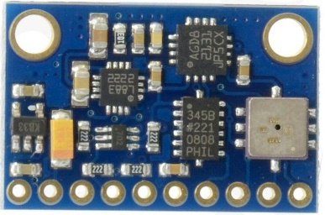 | Gy-801  - Three selectable full scales (250/500/2000dps)  - Factor in all g-ranges, up to 13-bit resolution at ±16 g  - 12-Bit ADC Coupled with Low Noise ARM Sensors Achieves 5 milli-gauss Resolution in ±8 Gauss Fields  - Pressure range: 300 to1100hPa (+9000m to -500m above sea level)  - I2C interfaces  - Power supply: 3-5v

This IMU 1DOF is based on the sensor L3G4200D, ADXL345, HMC5883L and BMP180.
The L3G4200D is a low-power three-axis angular rate sensor able to provide unprecedented stablility of zero rate level and sensitivity over temperature and time. It includes a sensing element and an IC interface capable of providing the measured angular rate to the external world through a digital interface (I2C/SPI).
The ADXL345 is a small, thin, low power, three-axis accelerometer with high resolution (13-bit) measurement up to 16g. It measures the static acceleration of gravity in tilt-sensing applications, as well as dynamic acceleration resulting from motion or shock. Its high resolution (4mg/LSB) enables resolution of inclination changes of as little as 0.25°. The Honeywell HMC5883L is designed for low-field magnetic sensing with a digital interface for applications such as low-cost compassing and magnetometry
The HMC5883L includes high-resolution HMC118X series magneto-resistive sensors plus an ASIC containing amplification, automatic degaussing strap drivers, offset cancellation, and a 12-bit ADC that enables 1° to 2° compass heading accuracy.
The BMP180 is the function compatible successor of the BMP085, a new generation of high precision digital pressure sensors for consumer applications. The ultra-low power, low voltage electronics of the BMP180 is optimized for use in mobile phones, PDAs, GPS navigation devices and outdoor equipment.
3.3.4 Motor
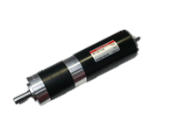 | Geared Motor IG-52GM 04TYPE (24V)  Rated Voltage: DC 24V  Rated Torque: Max. 100Kg-cm  Size: Ø54.3 * L 95.3mm  Shaft: Ø12mm, key-way 5 x 18mm  Reduction Ratio: 1/12  Rated Speed: 285 RPM  No Load Speed: 333 RPM

04 TYPE MOTOR (DC 24V)
Rated torque | 1,300 (gf-cm)
Rated speed | 3,550 (RPM)
Rated current | 2,850 (mA)
No load speed | 4,000 (RPM)
No load current | 700 (mA)
Rated output | 48.6 (W)

3.2.5 Encoder
CUI AMT103
- patented capacitive technology
- 16 dip switch programmable resolutions
- straight (radial) and right-angle (axial) versions
- 9 different mounting hole options for AMT102
- 6 different mounting hole options for AMT103
- low power consumption
- line driver output available (CUI-10XE-10)
- 40°C to 100°C operating temperature
- TTL voltage output
- modular package

Output phase difference | 90° (A ch leads B ch in CW direction viewed from front)
Output current | 5mA max.
Output waveform | TTL voltage square wave
Output signals | A, B, Z1 phase (A, B, C line driver available with CUI-10XE-10)
Current consumption | 6 mA typ., 10 mA max.
Supply voltage | 3.6 ~ 5.5 V dc
Output resolution (ppr) | 48, 96, 100, 125, 192, 200, 250, 256, 384, 400, 500, 512, 800, 1000, 1024, 2048
Frequency response | 250 kHz max
Accuracy | ±15 arc min (at 192, 384, 400, 500, 800, 1000, 1024, 2048 ppr) ±30 arcmin (at 96, 200, 250, 512 ppr) ±60 arcmin (at 48, 100, 125, 256 ppr)
Max. rotational speed | 7500 rpm (at 2048, 1000, 800, 384 ppr) 15000 rpm (at 1024, 500, 400, 192 ppr) 30000 rpm (at 48, 96, 100, 125, 200, 250, 256, 512 ppr)

3.2.6 Motor Driver
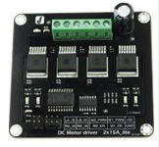 | DC Motor driver 2x15A_lite  - Input Voltage:4.8-35V  - Maximum output current: 15A@13.8V per channel  - Peak output current: 20A@13.8V per channel  - PWM capability: up to 25 kHz  - Interfaces: 4 digital IO(2 PWM output include)  - Driving mode: Dual high-power H-bridge driver  - Other specifications:  - Galvanic isolation to protect the microcontroller  - Dual current detection diagnostic functions  - Short circuit, overheating, over-voltage protection  - Size:73x68x14mm  - For applications of more than 15A per channel  - Fast switching might damage the board, best to smooth it by software  - Avoid higher rating motors, and use lower PWM whenever possible

3.2.7 Master Control Board
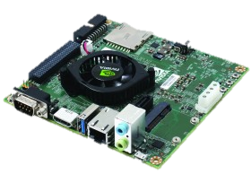 | NVIDIA Jetson tk1  - File system based in Ubuntu Linux kernel.  - Tegra K1 SOC (CPU+GPU+ISP in a single chip):  GPU: NVIDIA Kepler "GK20a" GPU with 192 SM3.2 CUDA cores  CPU: NVIDIA "4-Plus-1" 2.32GHz ARM quad-core Cortex-A15 CPU

Hardware Features:
Dimensions: 5" x 5" (127mm x 127mm) board
DRAM: 2GB DDR3L 933MHz EMC x16 using 64-bit data width
Storage: 16GB fast eMMC 4.51 (routed to SDMMC4)
mini-PCIe: a half-height single-lane PEX slot
SD/MMC card: a full-size slot (routed to SDMMC3)
USB 3.0: a full-size Type-A female socket
USB 2.0: a micro-AB female socket
HDMI: a full-size port
RS232: a full-size DB9 serial port (routed to UART4)
Audio: an ALC5639 Realtek HD Audio codec with Mic in and Line out jacks
Ethernet: a RTL8111GS Realtek 10/100/1000Base-T Gigabit LAN port using PEX
SATA: a full-size port that supports 2.5" and 3.5" disks, but is not hot-pluggable
JTAG: a 2x10-pin 0.1" port for professional debugging
Power: a 12V DC barrel power jack and a 4-pin PC IDE power connector
Fan: a fan-heatsink running on 12V
The following signals are available through the 125-pin 2mm-pitch expansion port:
Camera ports: 2 fast CSI-2 MIPI camera ports (one 4-lane and one 1-lane)
LCD port: LVDS and eDP Display Panel
Touchscreen ports: Touch SPI 1 x 4-lane + 1 x 1-lane CSI-2
UART
HSIC
I2C: 3 ports
GPIO: 7 x GPIO pins (1.8V). Camera CSI pins can also be used for extra GPIO
Hardware-accelerated APIs supported:
CUDA 6.0 (SM3.2, roughly the same as desktop SM3.5)
OpenGL 4.4
OpenGL ES 3.1
OpenMAX IL multimedia codec including H.264, VC-1 and VP8 through Gstreamer
NPP (CUDA optimized NVIDIA Performance Primitives)
OpenCV4Tegra (NEON + GLSL + quad-core CPU optimizations)
VisionWorks

In this version of Haaga, Jetson tk1 board is used to master controller for the object recognition and path planning by vision based algorithm. Jetson with GPU-accelerated parallel processing is the embedded visual computing platform. It features high-performance, low-energy computing for deep learning and computer vision making the Jetson platform ideal for compute-intensive embedded projects like drones, autonomous robotic system. Although vision algorithms are not encoded, you can freely write the codes using default systems by additional USB ports.
This board is connected with Bluno via serial communication. If you send the desired motor speed value as string command via serial communication, status of robot is returned as 1d array of string.

3.2.8 Camera
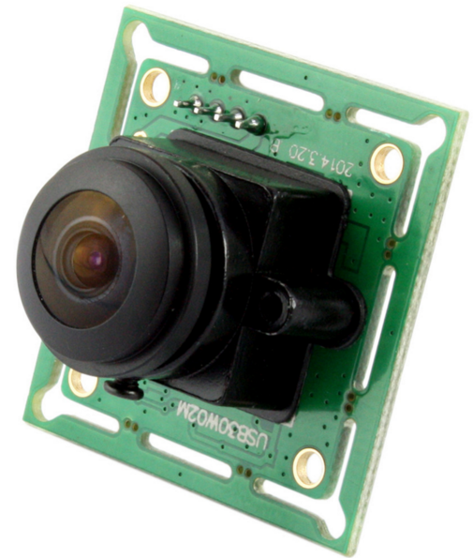 | Fisheye CMOS camera  Connector: USB 2.0  FOV: 170~190 deg  Resolution: 640x480  1280x960  1920x1080

FOV | 170 Degee
Sensor | 1/3" CMOS ov2710
Lens | 200w, 2.0 mega pixels, 1920(H) X1080( V) pixels
Max. Resolution | 1920x1080
Image Format | MJPEG
USB protocol | USB2.0 HS/ FS, usb1.1 FS
Driver support | USB Video class(UVC) 1.1
Auto exposure | Support
Auto white balance | Support
Frame rates | 1920(H) x 1080(V) pixel, MJPEG 30 fps, yuy2 6 fps  1280(H) x 1024(V) pixel, MJPEG 30 fps, yuy2 6 fps  1280(H) x 720(V) pixel, MJPEG 60 fps, yuy2 9 fps  1024(H) x 768(V) pixel, MJPEG 30 fps, yuy2 9 fps  800(H) x 600(V) pixel, MJPEG 60 fps, yuy2 21 fps  640(H) x 480(V) pixel, MJPEG 120 fps, yuy2 30 fps  352(H) x 288(V) pixel, MJPEG 120 fps, yuy2 30 fps  320(H) x 240(V) pixel, MJPEG 120 fps, yuy2 30 fps
Voltage | DC 5V
Current | 150mA
Operating temperature | Degree (- 20~70)
Dimension | 32x32mm/ 38*38
OS Support | winxp/ vista/ win7/ Win8  Linux UVC
3.2.9 Lidar
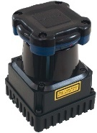 | Hokuyo UTM-30LX-EW  - Supply voltage 12V  - Measurement distance 30m  - Field of view 270°  - Interface Ethernet  - Multi-echo support

Light Source | Laser Semiconductor λ = 905nm Laser Class 1
Power Source | 12VDC ± 10%
Supply Current | MAX: 1A, Normal : 0.7A
Power Consumption | Less than 8W
Detection Range and Detection Object | Guaranteed Range:0.1 to 30m  Maximum Range:0.1 to 60m  Minimum detectable width at 10m : 130mm
Accuracy | 0.1 to 10m: ±30mm,10 to 30m : ±50mm  Under 3000lx : White Kent Sheet : ±30mm^{*1}(0.1 to 10m)  Under 100000lx : White Kent Sheet : ±50mm^{*1}(0.1 to 10m)
Measurement | 1mm
Resolution and Repeated Accuracy | 0.1 to 10m: σ<10mm, 10 to 30m: σ<30mm  Under 3000lx: σ=10mm  Under 100000lx: σ=30
Scan Angle | 270°
Angular Resolution | 0.25°(360°/1440)
Scan Speed | 25ms (Motor speed: 2400rpm)
Interface | Ethernet 100BASE-TX(Auto-negotiation)
Output | Synchronous Output 1-Point
Ambient Condition  (Temperature, Humidity) | -10 to +50 degrees C  Less than 85%RH (Without Dew, Frost)
Storage Temperature | -25 to +75 degrees C

4. ArduHaaga Firmware
The latest firmware for Haaga cleaning robot is available from the github. This page provides additional links to a number of specific builds that are considered “significant” - for example, the last builds of firmware to fit on the Bluno mega 2560 board.

4.1 Compile and Upload
To compile ‘ArduHaaga.ino’, you have to install following tools in the Linux kernel.
Tools need
- Arduino IDE
- TinyGPS
- HMC5883L
- ROS
  - ROSSerial

TinyGPS is library to acquire coordinates from GPS sensor and HMC5883L is library for robot’s heading from IMU.
The ROS (Robot Operating System) is a set of software libraries and tools that help you build haaga applications.
The ROSSerial is a protocol for wrapping standard ROS serialized messages and multiplexing multiple topics and services over a character device such as a serial port. Installation guide is in the Chapter 7.

4.2 Source
4.2.1 Functions
void setup()
The setup() function is called when a sketch starts. Use it to initialize variables, pin modes, start using libraries, etc. The setup function will only run once, after each powerup or reset of the Arduino board.
void loop()
After creating a setup() function, which initializes and sets the initial values, the loop() function does precisely what its name suggests, and loops consecutively, allowing your program to change and respond. Use it to actively control the Arduino board.
void rencoder1() & void rencoder2()
Get the encoder counter value from interrupt pins
void checkEvent()
In the every loop, check the commands which come from serial port.
void calculateRPM(String command)
From the command, check the desired value of motor speed.
void speedcalculation(unsigned long dt)
Calculate motor speed using encoder value

Parameters
- dt frequency of the firmware loop.
void buildVelProfile(float desired_vel, float current_vel, float *speed_profile)
Build the trapezoidal velocity profile of the motor.

Parameters
- desired_vel input value of the motor speed from string command.
- current_vel calculated value of the motor speed from encoder.
- speed_profile result value of the motor speed.
float updatePid( float targetValue, float currentValue, unsigned long dt, float Kp, float Ki, float Kd)
PID control function for the desired input data

Parameters
- targetValue desired value of the motor speed.
- current_Value calculated value of the motor speed from encoder.
- dt frequency of the firmware loop.
- Kp P gain
- Ki I gain
- Kd D gain

Return
PWM value of the motor
float lpFilter(float value, float prev_value, float beta)
Pass the signals of the encoder value using Low-pass algorithm

Parameters
- value raw data
- prev_value filtered previous data
- beta filtered coefficient

Return
Filtered data
void gpsdump(TinyGPS &gps)
Create the TinyGPS object and get the GPS coordinates.
void callback(const Test::Request &req, Test::Response &res)
Check the request and response messeages from the ROS topic
void publishStatus()
Send the robot’s status (motor speed, heading, coordinates) to the ROS topic.

4.2.2 The Code Explained
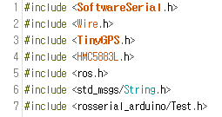
As a part of every ROS Arduino program, you need to include the ‘ros.h’ header file and header files for string messages that you will be using.
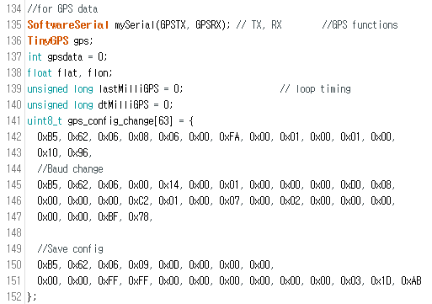
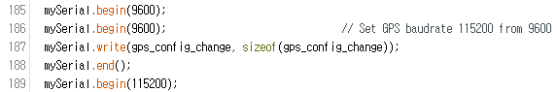
Figure 5. Initialize GPS serial communication
The above codes are initialization of the GPS sensor in the Bluno board. GPS’s TX is connected to 11 pin of Bluno and RX is connected to 10 pin. For the increasing of GPS data transfer speed, GPS baudrate should be 115200 (default is 9600). If GPS baudrate is lower than 115200, main loop frequency will decrease.

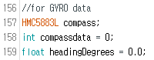
Figure 6. Variables for Gyro sensor
There are many outputs from IMU sensor. In this system, we just get the heading of robot using HMC5883L chip. The type of ‘compassdata’ variable is Boolean and that variable means status of connection with sensor. The value of robot’s heading will be stored in ‘’headingDegrees’.

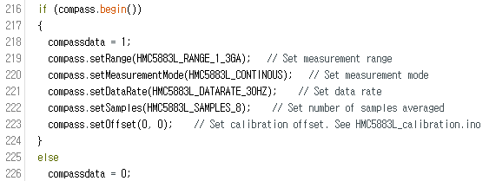
In the setup function, you can set the variables of measurement range, mode, frequency, samples and offset.

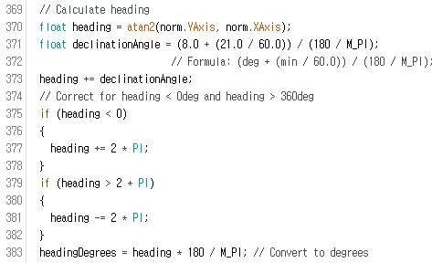
Calculate heading when the magnetometer is level, then correct for signs of axis. Atan2() function automatically check the correct formula taking care of the quadrant you are in. Once you have robot’s heading, you must add your ‘Declination angle’ which is the error of the magnetic field in your location. Find yours here: http://www.magnetic-declination.com/. If you find your declination, modify the formula of line 354.

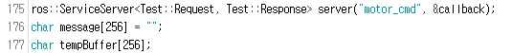
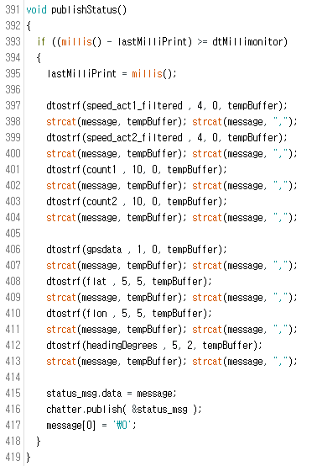
In the publishStatus function, ‘motor_cmd’ node publishes status of the Haaga and calls spinOnce() where all of the ROS communication callbacks are handled.

5. Applications
This chapter provides basic information of the applications for Haaga robot.

5.1 Haaga Controller
This application is controller of the Haaga cleaning robot using BLE of the Bluno mega for the Android mobile.

5.1.1 Using the App in your Android
Steps for Android
- Install the APK file into your Android phone.
- Run the application.
- Click the ‘Scan’ button for scanning and select the device.
- After connected, Click the directional buttons. The default RPM of the motor is 50 and can be changed using the slide.
- The Bluno will reply with the command. Thus you can see the same "received data"
- You can send the commands to modify PID gain using text box.
- Notice that the board RX and TX led will blink when sending and receiving the message.

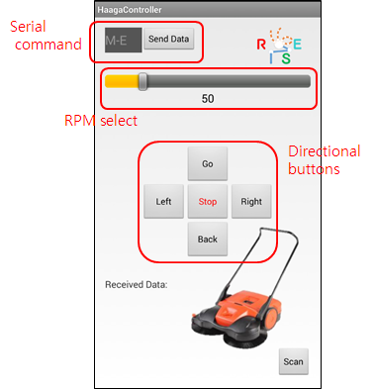
Figure 7. Haaga controller Application

5.1.2 Project setup and Compile

If you want to recompile the application on Android device, you will need the Android Studio with the followings.
Requirements
- Bluno library
- Android 4.3+
Download the source code from the github and open the project ‘HaagaController’ in the IDE.
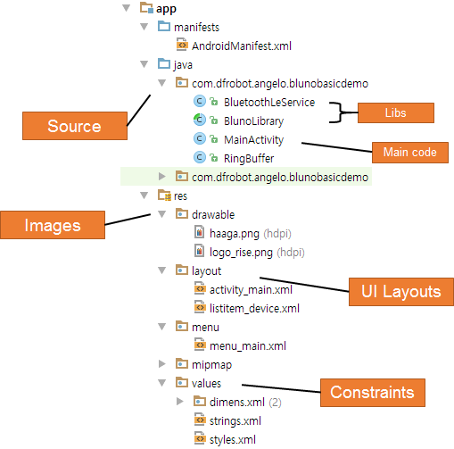
Figure 8. File Structure of application

Go to this site for more tutorials of the BlunoLibrary.
http://www.dfrobot.com/wiki/index.php/Bluno_SKU:DFR0267

5.2 Fisheye Camera Calibration
Two fisheye cameras are attached in front of the Haaga. If you want to calibrate the cameras, this application will help you. The source of calibration is in the github.

Requirements
- C++ compilation environments properly set
- OpenCV installed (3.0 or higher)

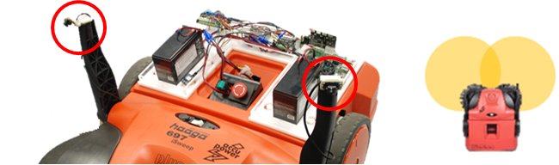
Figure 11. Camera setup and FOV

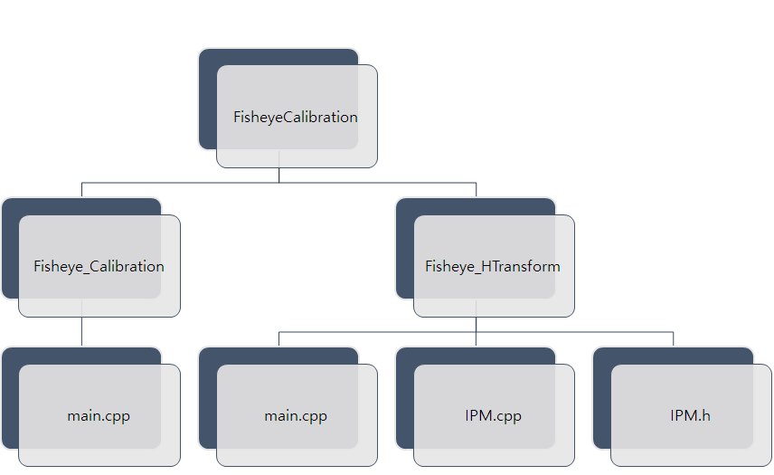
Figure 9. File Structure of FisheyeCalibration Project
5.2.1 Fisheye_Calibration
This application will
- Determine the distortion matrix
- Determine the camera matrix
- Take input from Image file list or Camera
- Read configuration from XML file
- Save the results into XML file
Usage:
Fisheye_Calibration [settings.xml] [imagelists.xml]
Output:
Out_camera_data.xml
This program has a single argument: the name of its configuration file. If none is given, then it will try to open the one named “default.xml”. We provide the configuration file (setting.xml) in XML format. In the configuration file you may choose to use camera as an input or an image list.
Let there be this input chessboard pattern which has a size 9x6. From the fisheye camera, images are saved into the Images folder and imagelists.xml file is created that describes which images to use:
Imagelists.xml
<?xml version="1.0"?>
<opencv_storage>
<images>
Images/images1.png
Images/images2.png
Images/images3.png
Images/images4.png
Images/images5.png
</images>
</opencv_storage>

Here’s a chessboard pattern found during the runtime of the application:
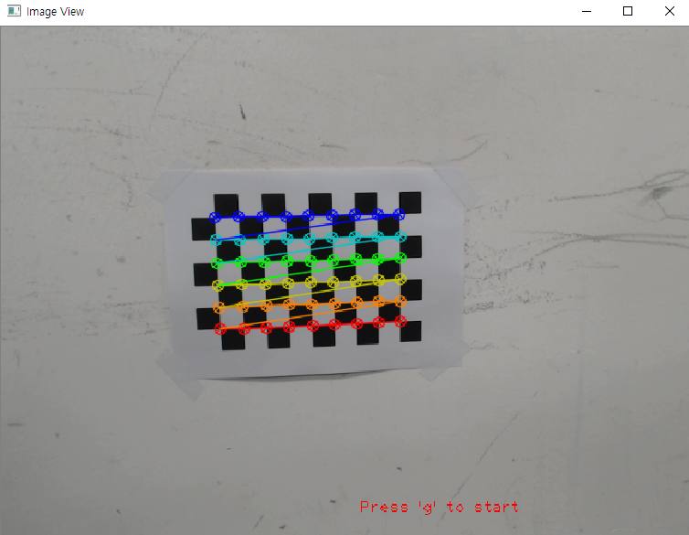
Figure 10. Detected pattern
After running of this program, you’ll find the camera and distortion coefficients matrices from the out_camera_data.xml.

5.2.2 Fisheye_HTransform
This application will
- Determine the Homography matrix to transform
- Read camera matrix of Right and Left fisheye camera
- Save the result into XML file

Usage:
Fisheye_HTransform [right_camera_data.xml] [left_camera_data.xml] [image_r.bmp] [image_l.bmp] [point_lists.xml]
Output:
H_matrix.xml
The argument files ‘right_camera_data.xml’ and ‘left_camera_data.xml’ are the results acquired from Fisheye_Calibration.xml. The point_lists.xml file is containing the coordinates of image pixel of the fisheye camera and around view image. You can see the XML format in the following table and order of the points is clockwise as shown in the Fig 13. The ‘pts_obj’ is pixel coordinates of undistortion image and ‘pts_dst’ is pixel coorThe type of the points is float.
Point_lists.xml
<?xml version="1.0"?>
<opencv_storage>
<R_pts_obj>
point1.x point1.y point2.x point2.y point3.x point3.y point4.x point4.y</R_pts_obj>
<R_pts_dst>
point1.x point1.y point2.x point2.y point3.x point3.y point4.x point4.y</R_pts_dst>
<L_pts_obj>
point1.x point1.y point2.x point2.y point3.x point3.y point4.x point4.y</L_pts_obj>
<L_pts_dst>
point1.x point1.y point2.x point2.y point3.x point3.y point4.x point4.y</L_pts_dst>
</opencv_storage>

Using ‘left_camera.xml’ and ‘right_camera.xml’ which has intrinsic and extrinsic parameters, this application can remove the distortion effect. As a result, you’ll find the homography matrix from the saved XML file.

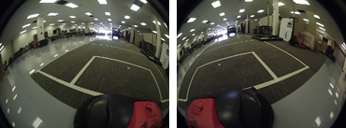
Figure 11. Distortion Image of Fisheye Camera
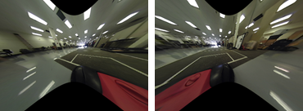
Figure 12. Undistortion Image of Fisheye Camera
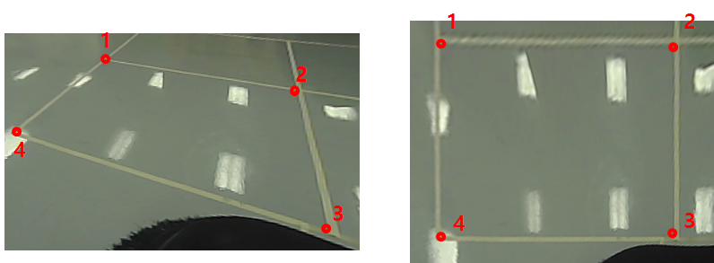
Figure 13. Left: Undistortion Image, Right: Transformed Image by Homography matrix

6. Tutorials
6.1 AroundViewer

From the previous chapter, we can get the camera matrix and homography transformation matrix to build around-view image. This example is the code that build the around-view image using two fisheye cameras which are attached to the Haaga robot.

Code Explanation
#include <opencv2/opencv.hpp>
#include <opencv2/highgui/highgui.hpp>
#include <opencv2/core/core.hpp>
1. To compile this example, you need to install OpenCV Library 3.0 or higher and include the headers.
const string camera_light_file ="calibration/right_camera.xml";
const string camera_left_file = "calibration/left_camera.xml";
const string topview_file = "calibration/H.xml";

FileStorage fs_R(camera_light_file, FileStorage::READ); // Read the settings
FileStorage fs_L(camera_light_file, FileStorage::READ);
FileStorage fs_H(topview_file, FileStorage::READ);

readData_R(fs_R);
readData_L(fs_L);
readData_H(fs_H);
2. Above three XML files are results of the ‘Fisheye_Calibration’ application. From the saved files, camera matrix and homography matrix are loaded.

cv::VideoCapture cap_R(argv[1]);
cv::VideoCapture cap_L(argv[2]);
if (!cap_R.isOpened() || !cap_L.isOpened())
return -1;

cap_R.set(CV_CAP_PROP_FOURCC, CV_FOURCC('M', 'J', 'P', 'G'));
cap_R.set(CV_CAP_PROP_FRAME_WIDTH, imageWidth);
cap_R.set(CV_CAP_PROP_FRAME_HEIGHT, imageHeight);
cap_L.set(CV_CAP_PROP_FOURCC, CV_FOURCC('M', 'J', 'P', 'G'));
cap_L.set(CV_CAP_PROP_FRAME_WIDTH, imageWidth);
cap_L.set(CV_CAP_PROP_FRAME_HEIGHT, imageHeight);
3. cv::VideoCapture is the class for video capturing from video files, image sequences or cameras. The class provides C++ API for capturing video from cameras or for reading video files and image sequences. First argument is camera port of right camera and second argument is left.
VideoCapture.set is the function that set a property
- CV_CAP_PROP_FRAME_WIDTH Width of the frames in the video stream.
- CV_CAP_PROP_FRAME_HEIGHT Height of the frames in the video stream.
- CV_CAP_PROP_FOURCC 4-character code of codec.
If you want to increase quality of video steam, you can modify size of resolution and code of codec to ‘I’, ‘Y’, ‘U’, ‘V’.

Mat newCamMat_R, newCamMat_L;
float dummy_query_data_R[10] = { 156.00713303635887, 0, 139.5047668805756, 0, 155.83043278608287, 305.505831367789, 0, 0, 1 };
float dummy_query_data_L[10] = { 156.00713303635887, 0, 439.5047668805756, 0, 155.83043278608287, 305.505831367789, 0, 0, 1 };

newCamMat_R = cv::Mat(3, 3, CV_32F, dummy_query_data_R);
newCamMat_L = cv::Mat(3, 3, CV_32F, dummy_query_data_L);

fisheye::undistortImage(frame_R, undistorted_frame_R, cameraMatrix_R, distCoeffs_R, newCamMat_R, cv::Size(frame_R.cols*scale, frame_R.rows*scale));
fisheye::undistortImage(frame_L, undistorted_frame_L, cameraMatrix_L, distCoeffs_L, newCamMat_L, cv::Size(frame_L.cols * scale, frame_L.rows * scale));
4. The ‘dummy_query_data’ is camera matrix to build new camera matrix for undistortion and elements are as follows.
$$Camera Matrix= \left[\begin{matrix}f_{x} & 0 & c_{x} \\ 0 & f_{y} & c_{y} \\ 0 & 0 & 1\end{matrix}\right]$$
Where $f_{x}$ and $f_{y}$ are the focal lengths and $c_{x}$ and $c_{y}$ are the principal point that is usually at the image center. The function cv::fisheye::undistortImage is that transform an image to compensate for fisheye lens distortion.
void cv::fisheye::undistortImage(InputArray distorted, OutputArray undistorted, InputArray K, InputArray D, InputArray Knew = cv::noArray(), const Size &new_size = Size())
- distorted: image with fisheye lens distortion.
- undistorted: Output image with compensated fisheye lens distortion.
- K: Camera matrix
- D: Input vector of distortion coefficients (k1, k2, k3, k4).
- Knew: Camera matrix of the distorted image. By default, it is the identity matrix but you may additionally scale and shift the result by using a different matrix.
- new_size: The function transforms an image to compensate radial and tangential lens distortion.

cv::warpPerspective(undistorted_frame_R, topview_R, right_H, cv::Size(frame_R.cols, frame_R.rows));
cv::warpPerspective(undistorted_frame_L, topview_L, left_H, cv::Size(frame_L.cols, frame_L.rows));

roi_R = topview_R(cv::Rect(topview_R.cols / 2, 0, topview_R.cols / 2, topview_R.rows));
roi_L = topview_L(cv::Rect(0, 0, topview_R.cols / 2, topview_R.rows));
roi_R.copyTo(topview(cv::Rect(topview.cols / 2, 0, topview.cols / 2, topview.rows)));
roi_L.copyTo(topview(cv::Rect(0, 0, topview_R.cols / 2, topview_R.rows)));

cv::imshow("topview", topview);
5. cv::wawrpPerspective is the function that applies a perspective transformation to an image.
void warpPerspective(InputArray src, OutputArray dst, InputArray M, Size dsize, int flags=INTER_LINEAR, int borderMode=BORDER_CONSTANT, const Scalar& borderValue=Scalar())
- src: input image.
- dst: output image that has the size dsize and the same type as src .
- M: 3x3 transformation matrix.
- dsize: size of the output image.
- flags: combination of interpolation methods (INTER_LINEAR or INTER_NEAREST) and the optional flag WARP_INVERSE_MAP, that sets M as the inverse transformation
- borderMode: pixel extrapolation method (BORDER_CONSTANT or BORDER_REPLICATE).
- borderValue: value used in case of a constant border; by default, it equals 0.
The undistortion images of the right and left image are need to be transformed. Then get the region of interest of each image and copy to the null image. The result of around-view image is shown as Fig. 15.

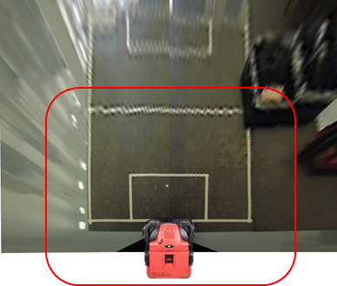
Figure 15. Around view Image

6.2 LineFollower

This example helps Haaga robot to set the appropriate direction by extract the curb in the road environment. The input is around-view image acquired from ‘AroundViewer’.

Code Explanation
cv::Mat img = imread(argv[1]);
cv::Mat img_gray, img_blur, img_canny;
1. Load the source (around-view) image and create a matrix of same size.
2. Convert the image to grayscale (using the function cvtColor).

void setwindowSettings() {
cv::namedWindow("canny_var", 100);
cv::createTrackbar("threshold1", "canny_var", &threshold1, 500, NULL);
cv::createTrackbar("threshold2", "canny_var", &threshold2, 500, NULL);
cv::createTrackbar("blur", "canny_var", &gaussblur, 20, NULL);
}
3. Create a trackbar window for the user to enter the threshold for Canny detector and Gaussian blur.

cv::cvtColor(img, img_gray, CV_BGR2GRAY);
cv::GaussianBlur(img_gray, img_blur, cv::Size(gaussblur*2-1, gaussblur*2-1), 3);
cv::Canny(img_blur, img_canny, threshold1, threshold2, 3);
4. Blur the gray image with a filter kernel (size must be odd) and extract edge using cv::Canny function.

void cvtColor(InputArray src, OutputArray dst, int code, int dstCn=0 )
Converts an image from one color space to another
- src : input image: 8-bit unsigned, 16-bit unsigned ( CV_16UC... ), or single-precision floating-point.
- dst : output image of the same size and depth as src.
- code: color space conversion code
- dstCn : number of channels in the destination image; if the parameter is 0, the number of the channels is derived automatically from src and code

void GaussianBlur(InputArray src, OutputArray dst, Size ksize, double sigmaX, double sigmaY=0, int borderType=BORDER_DEFAULT )
Blurs an image using a Gaussian filter
- src : input image; the image can have any number of channels, which are processed independently, but the depth should be CV_8U, CV_16U, CV_16S, CV_32F or CV_64F.
- dst : output image of the same size and type as src.
- ksize : Gaussian kernel size. ksize.width and ksize.height can differ but they both must be positive and odd.
- sigmaX : Gaussian kernel standard deviation in X direction.
- sigmaY : Gaussian kernel standard deviation in Y direction
- borderType : pixel extrapolation method

void Canny(InputArray image, OutputArray edges, double threshold1, double threshold2, int apertureSize=3, bool L2gradient=false )
Finds edges in an image using the algorithm.
- Image: single-channel 8-bit input image.
- edges: output edge map; it has the same size and type as image.
- threshold1: first threshold for the hysteresis procedure.
- threshold2: second threshold for the hysteresis procedure.
- apertureSize: aperture size.
- L2gradient: a flag, indicating whether a more accurate.

vector<Vec4i> lines;
cv::HoughLinesP(img_canny, lines, 1, CV_PI / 180, 50, 20, 10);
5. Apply the transform with the arguments:
void HoughLinesP(InputArray image, OutputArray lines, double rho, double theta, int threshold, double minLineLength=0, double maxLineGap=0 )
- dst: Output of the edge detector. It should be a grayscale image.
- lines: A vector that will store the parameters ($x_{1},y_{1},x_{2},y_{2}$) of the detected lines
- rho : The resolution of the parameter r in pixels. We use 1 pixel.
- theta: The resolution of the parameter \theta in radians. We use 1 degree (CV_PI/180)
- threshold: The minimum number of intersections to “detect” a line
- minLinLength: The minimum number of points that can form a line. Lines with less than this number of points are disregarded.
- maxLineGap: The maximum gap between two points to be considered in the same line.
To detect the line, we use the ‘HoughLinesP’ function that more efficient implementation of the Hough Line Transform. It gives as output the detected lines.

std::vector<int> candidates;
for (size_t i = 0; i < lines.size(); i++)
{
if ((lines[i][2] > 430 && lines[i][0] > 430) && (lines[i][1] > img.rows / 2 && lines[i][3] > img.rows / 2))
candidates.push_back(i);
}
6. Then set the limit condition to remove outlier lines.

int minidx = 0;
if (candidates.size() > 1)
{
for (size_t i = 1; i < candidates.size(); i++)
{
if (lines[candidates[minidx]][0]>lines[candidates[i]][0])
minidx = i;
}
}
else if (candidates.size() == 1)
minidx = 0;
7. Using the candidate lines, sort the candidates in the order closer to the Haaga and save the index.

if (candidates.size()>0)
{
Vec4i l = lines[candidates[minidx]];
float dx, dy;
float length, deg, theta;
dy = l[2] - l[0];
dx = l[1] - l[3];
theta = atan2f(dy, dx);
if (theta * 180 / CV_PI > 90)
deg = -1 * (180 - theta * 180 / CV_PI);
else
deg = theta * 180 / CV_PI;
line(result, Point(l[0], l[1]), Point(l[2], l[3]), Scalar(0, 0, 255), 2, CV_AA);
}
8. Calculate direction of the line using atan2() function and convert to deg from radian.

String headingText="Heading=";
stringstream ss;
ss << deg;
headingText += ss.str();
cv::putText(result, headingText, cv::Point(lines[candidates[minidx]][0],
lines[candidates[minidx]][1]), FONT_HERSHEY_PLAIN, 1.1,
cv::Scalar(0, 0, 255));
imshow("source", img);
imshow("detected lines", result);
9. Then display our result to image window.

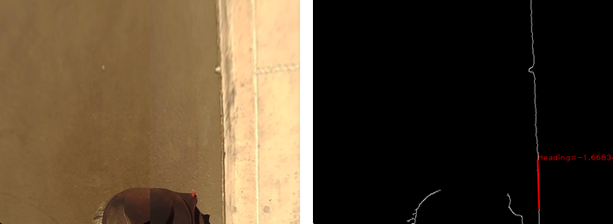
Figure 14. LineFollower results (Right) Input Around-view image
(Left) Detected curb edge and direction

7. ROS Programming
The Robot Operative System (ROS) is an open-source, meta-operating system for your robot maintained by the Open Source Robotics Foundation (OSRF). It provides the services you would expect from an operating system, including hardware abstraction, low-level device control, implementation of commonly-used functionality, message-passing between processes, and package management. It also provides tools and libraries for obtaining, building, writing, and running code across multiple computers. A ROS system is comprised of a number of independent nodes, each of which communicates with the other nodes using a publish/subscribe messaging model.

The ROS Master allows all other ROS pieces of software (Nodes) to find and talk to each other. Without the Master, nodes would not be able to find each other, exchange messages, or invoke services.

7.1 ROSSerial
The ‘rosserial’ is a protocol for wrapping standard ROS serialized messages and multiplexing multiple topics and services over a character device such as a serial port or network socket.
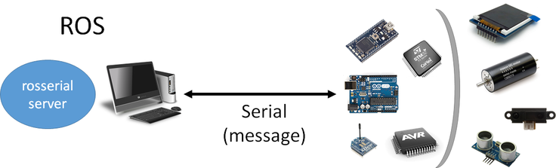
Figure 15. Structure of the rosserial
Installation

$ sudo apt-get install ros-indigo-rosserial ros-indigo-rosserial-server ros-indigo-rosserial-arduino
You can install rosserial for Arduino.

$cd /catkin_ws/src
$git clone https://github.com/ros-drivers/rosserial.git
$cd /catkin_ws/
$catkin_make
$catkin_make install
$source /catkin_ws/install/setup.bash
These commands clone rosserial from the github repository, generate the rosserial_msgs needed for communication, and make the ros_lib library.

$cd /Arduino/libraries
$rm -rf ros_lib
$rosrun rosserial_arduino make_libraries.py .
Install the ros_lib into the Arduino Environment.

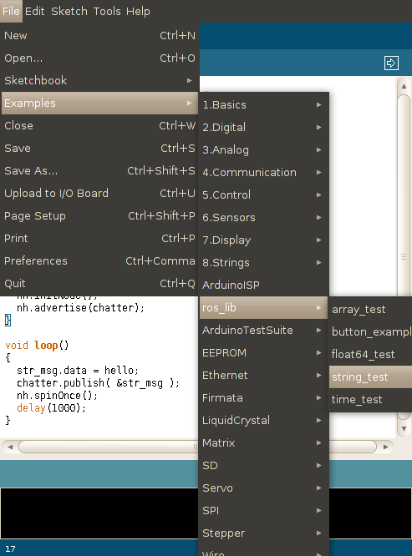
Figure 16. ros_lib library in the Arduino IDE
7.2 Commnunication between Bluno and Jetson
Let’s try to communicate with Bluno (Haaga firmware installed) in the Jetson tk1 board.

cd /catkin_ws/src
catkin_create_pkg ros_arduino rospy
catkin_make
cd /catkin_ws/src/ros_arduino
mkdir src
gedit serial_node.py
Create ros_arduino pakage and build in the catkin workspace and write the below code to the serial_node.py file.

Code
#!/usr/bin/env python

import rospy
from rosserial_python import SerialClient, RosSerialServer
import multiprocessing

import sys

if __name__=="__main__":

rospy.init_node("arduino_node")
rospy.loginfo("ROS Serial Python Node")

port_name = rospy.get_param('~port','/dev/ttyUSB0')
baud = int(rospy.get_param('~baud','57600'))

sys.argv = rospy.myargv(argv=sys.argv)
if len(sys.argv) > 1 :
port_name = sys.argv[1]
baud = int(sys.argv[2])

rospy.loginfo("Connecting to %s at %d baud" % (port_name,baud) )
client = SerialClient(port_name, baud)
try:
client.run()
except KeyboardInterrupt:
pass

port_name = rospy.get_param('~port','/dev/ttyUSB0')
baud = int(rospy.get_param('~baud','57600'))
Set the default port is /dev/ttyUSB0 and baudrate is 57600.

sys.argv = rospy.myargv(argv=sys.argv)
if len(sys.argv) > 1 :
port_name = sys.argv[1]
tcp_portnum = int(sys.argv[2])
rospy.loginfo("Connecting to %s at %d baud" % (port_name,baud) )
client = SerialClient(port_name, baud)
Load the arguments and modify the port_name and baud variables.

try:
client.run()
except KeyboardInterrupt:
pass
Try to connect via serial port until interrupt occurs.

Usage:

$roscore
Open the terminal and start ROS master

$cd /catkin_ws/src/ros_arduino/src
$python serial_node.py /dev/ttyACM0 57600
Open the new terminal and run the ROS node with your serial port argument.

$rostopic list
$rosservice list
You can find the ros message lists (/motor_status topic and /motor_cmd service).

$rostopic echo /motor_status
From the /motor_status topic, you get the Haaga robot status.

$rosservice call /motor_cmd R50L50E
Through the /motor_cmd service, you can send the command to rotate the motor.

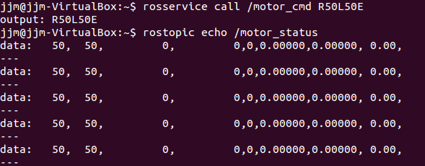
Figure 17. Communication with Bluno

7.3 LineFollower with ROS
7.3.1 The code
Create a src directory in the linefollower tutorials package directory:
cd ~/catkin_ws/src/ linefollower/src

Create the src/follower.cpp file within the linefollower package and paste the following inside it:
#pragma once
#include <iostream>
#include <sstream>
#include <time.h>
#include <stdio.h>
#include <vector>

#include <opencv2/core.hpp>
#include <opencv2/core/utility.hpp>
#include <opencv2/imgproc.hpp>
#include <opencv2/calib3d.hpp>
#include <opencv2/imgcodecs.hpp>
#include <opencv2/videoio.hpp>
#include <opencv2/highgui.hpp>

#include "ros/ros.h"
#include " rosserial_arduino/Test.h"
#include "std_msgs/String.h"

using namespace cv;
using namespace std;

int threshold1 = 25;
int threshold2 = 100;
int gaussblur = 5;
float deg;

void setwindowSettings() {
cv::namedWindow("canny_var", 100);

cv::createTrackbar("threshold1", "canny_var", &threshold1, 500, NULL);
cv::createTrackbar("threshold2", "canny_var", &threshold2, 500, NULL);
cv::createTrackbar("blur", "canny_var", &gaussblur, 20, NULL);
}

void chatterCallback(const std_msgs::String::ConstPtr& msg)
{
std::cout << ("Robot status: [%s]", msg->data.c_str())std::endl;
}

int main(int argc, char** argv)
{
cv::Mat img = imread(argv[1]);
cv::Mat img_gray, img_blur, img_canny;
float heading = 0.0;
string cmd=””;
ros::init(argc, argv, "listener");
ros::NodeHandle n;
ros::Subscriber sub = n.subscribe("motor_status", 1000, chatterCallback);
ros::ServiceClient client = n.serviceClient<rosserial_arduino::Test>("motor_cmd");
rosserial_arduino::Test srv;

while (1)
{
setwindowSettings();

Mat result;

cv::cvtColor(img, img_gray, CV_BGR2GRAY);
cv::GaussianBlur(img_gray, img_blur, cv::Size(gaussblur*2-1, gaussblur*2-1), 3);
cv::Canny(img_blur, img_canny, threshold1, threshold2, 3);

cvtColor(img_canny, result, CV_GRAY2BGR);

vector<Vec4i> lines;
cv::HoughLinesP(img_canny, lines, 1, CV_PI / 180, 50, 20, 10);
std::vector<int> candidates;
for (size_t i = 0; i < lines.size(); i++)
{
if ((lines[i][2] > 430 && lines[i][0] > 430) && (lines[i][1] > img.rows / 2 && lines[i][3] > img.rows / 2))
candidates.push_back(i);
}
int minidx = 0;
if (candidates.size() > 1)
{
for (size_t i = 1; i < candidates.size(); i++)
{
if (lines[candidates[minidx]][0]>lines[candidates[i]][0])
minidx = i;
}
}
else if (candidates.size() == 1)
minidx = 0;

if (candidates.size()>0)
{
Vec4i l = lines[candidates[minidx]];
float dx, dy;
float length, theta;
dy = l[2] - l[0];
dx = l[1] - l[3];
theta = atan2f(dy, dx);
if (theta * 180 / CV_PI > 90)
deg = -1 * (180 - theta * 180 / CV_PI);
else
deg = theta * 180 / CV_PI;
line(result, Point(l[0], l[1]), Point(l[2], l[3]), Scalar(0, 0, 255), 2, CV_AA);
}

String headingText="Heading=";
stringstream ss;
ss << deg;
headingText += ss.str();
cv::putText(result, headingText, cv::Point(lines[candidates[minidx]][0], lines[candidates[minidx]][1]), FONT_HERSHEY_PLAIN, 1.1, cv::Scalar(0, 0, 255));
imshow("source", img);
imshow("detected lines", result);

float right_speed,left_speed;
stringstream ss_r,ss_l;
right_speed=50-deg;
left_speed=50+deg;
ss_r << right_speed; ss_l<<left_speed;
heading=”R”+ss_r.str()+”L”+ss_l.str()+”E”;
srv.request = heading
if (client.call(srv))
{
ROS_INFO("Sum: %s", srv.response);
}
else
{
ROS_ERROR("Failed to call service motor_cmd");
}
heading=””;

char c = (char)cv::waitKey(10);
if (c == 'q')
break;
ros::spin();
}

return 1;
}

7.3.1 Code Explained
void chatterCallback(const std_msgs::String::ConstPtr& msg)
{
std::cout << ("Robot status: [%s]", msg->data.c_str())std::endl;
}
This is the callback function that will get called when a new message has arrived on the chatter topic. The message is passed in a boost shared_ptr, which means you can store it off if you want, without worrying about it getting deleted underneath you, and without copying the underlying data.

ros::Subscriber sub = n.subscribe("motor_status", 1000, chatterCallback);
Subscribe to the chatter topic with the master. ROS will call the chatterCallback() function whenever a new message arrives. The 2nd argument is the queue size, in case we are not able to process messages fast enough. In this case, if the queue reaches 1000 messages, we will start throwing away old messages as new ones arrive.

ros::ServiceClient client = n.serviceClient<rosserial_arduino::Test>("motor_cmd");
This creates a client for the motor_cmd service. The ros::ServiceClient object is used to call the service later on.

rosserial_arduino::Test srv;
srv.request = heading
Here we instantiate an auto-generated service class, and assign values into its request member. A service class contains two members, request and response. It also contains two class definitions, Request and Response.

if (client.call(srv))
This calls the service. Since service calls are blocking, it will return once the call is done. If the service call succeeded, call() will return true and the value in srv.response will be valid. If the call did not succeed, call() will return false and the value in srv.response will be invalid.

ros::spin();
ros::spin() enters a loop, calling message callbacks as fast as possible. Don't worry though, if there's nothing for it to do it won't use much CPU. ros::spin() will exit once ros::ok() returns false, which means ros::shutdown() has been called, either by the default Ctrl-C handler, the master telling us to shutdown, or it being called manually.

