This tutorial will demonstrate how to set up the radios.

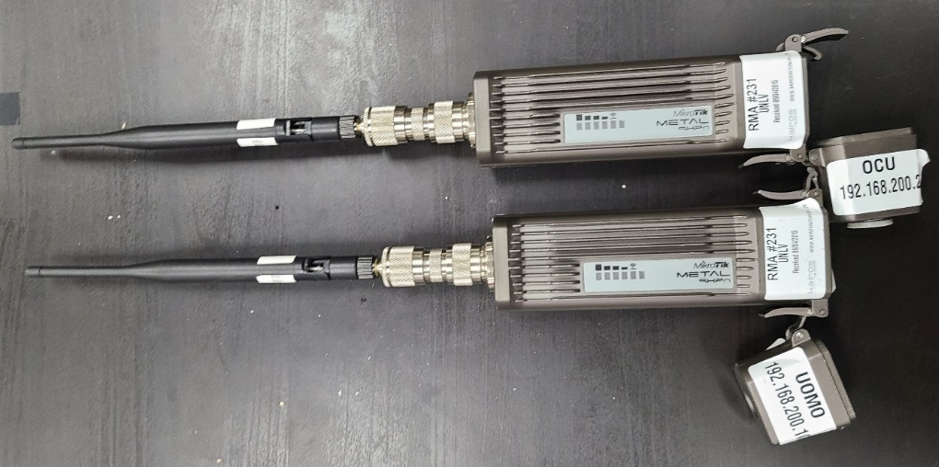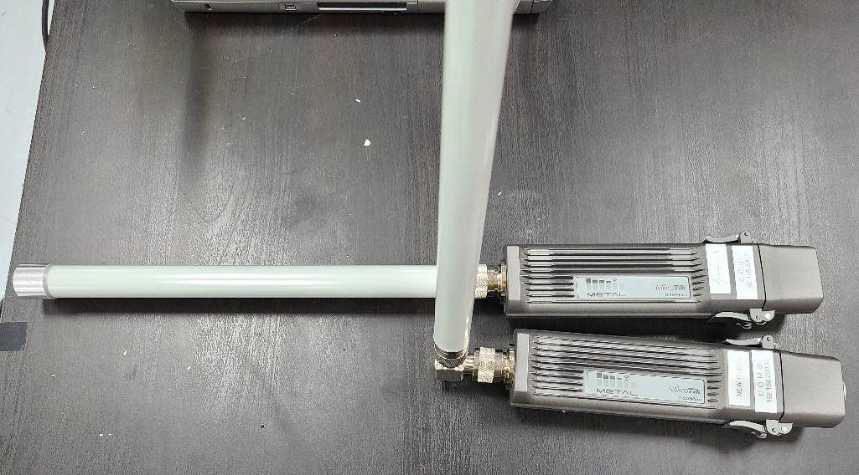
Figure 1. Old Radio Figure 2. New Radio

You need 2 radios to telecommunicate OCU with Uomo.

Radio need PoE. The Ethernet cable level must be higher than CAT 5e. (e.g., CAT 6)

Radio connecting to Uomo doesn’t need PoE injector.

Radio connecting with OCU should be connected with the PoE injector.
One Ethernet cable from OCU must go to LAN part in the PoE injector.

One Ethernet cable from radio must go to PoE part in the PoE injector.

After connecting light will beep and 10~20 seconds later light will beep one more time.

It means booted after 2 times of beeping.

After 2 radios are booted, they’ll recognize each other.

Troubleshooting

If the radios are not working, run ‘Winbox’ to solve it.

- Radio for Uomo
When you first run ‘Winbox’ you’ll see this window.
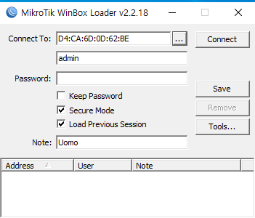
- Click button
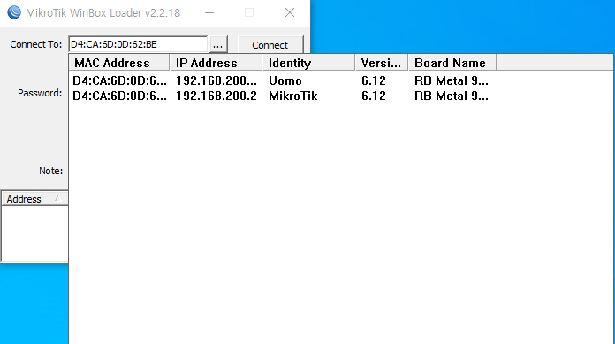
- Click ‘MAC Address’ or ‘IP Address’.
- Click ‘Connect’ button.

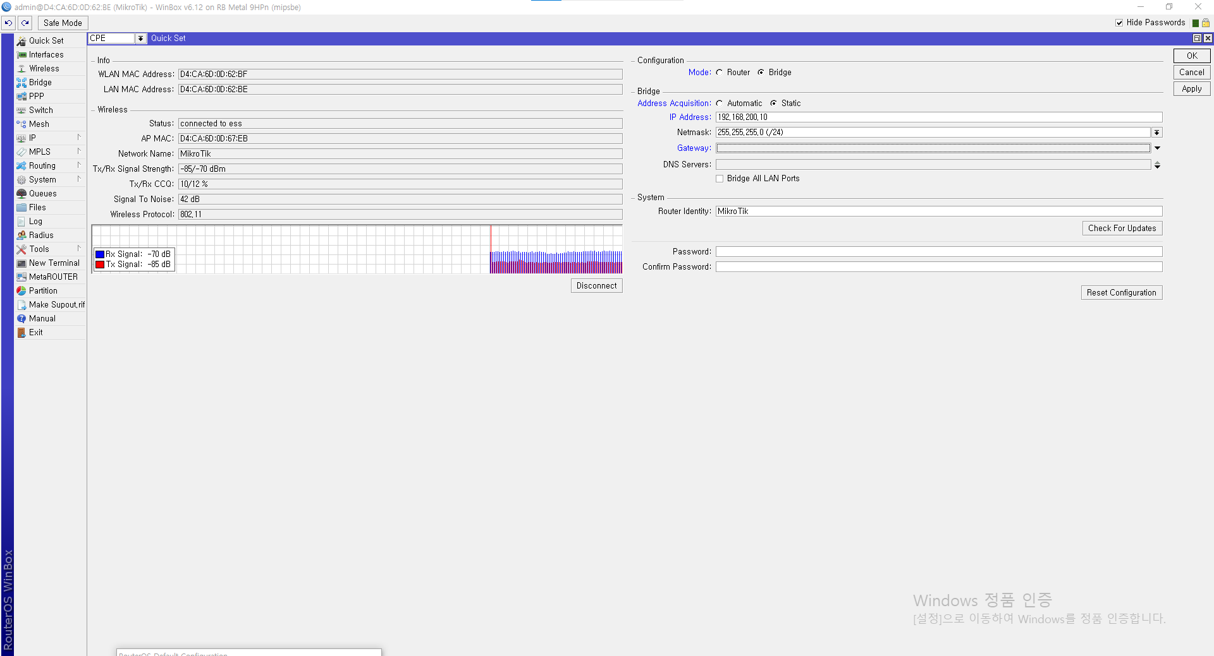
- Click ‘Quick Set’ button in the left.
- Check mode is ‘CPE’ in the top
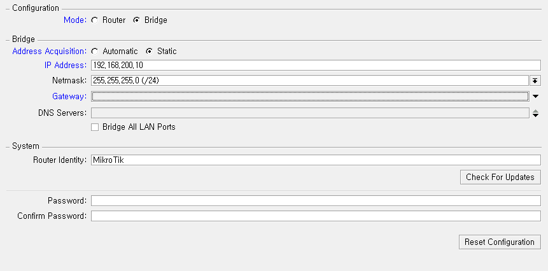
- In the Configuration tap check ‘Bridge’ mode.
- In the Bridge tap check ‘Static’ mode.
- In the Bridge tap put ‘IP Address’ ‘192.168.200.10’
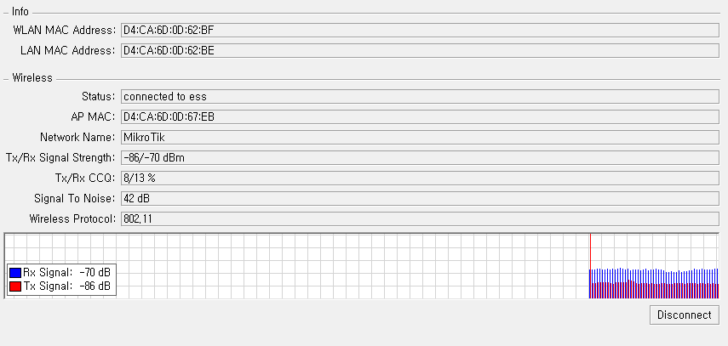
- In the ‘Wireless’ tap you can see if radios are interconnected.

- Radio for OCU
When you first run ‘Winbox’ you’ll see this window.
- Click button
- Click ‘MAC Address’ or ‘IP Address’.
- Click ‘Connect’ button.
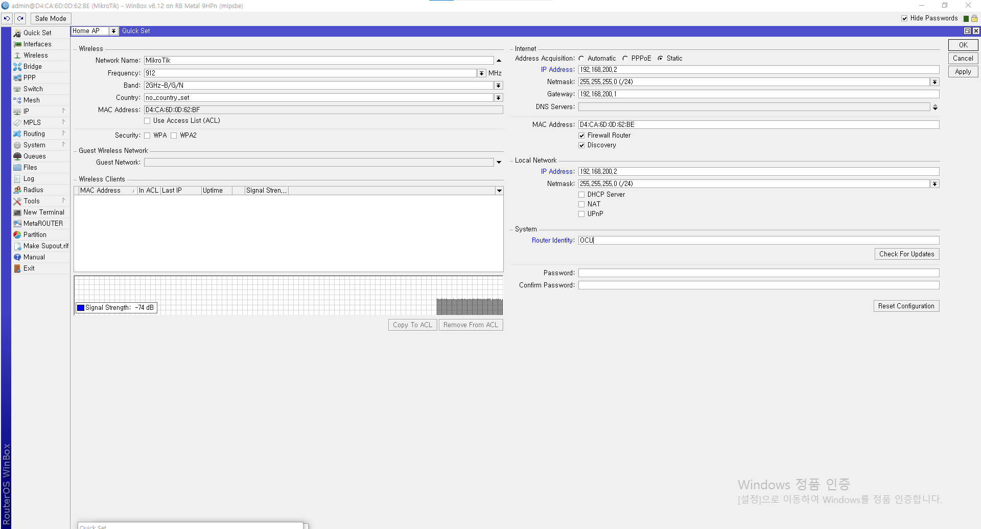
- Click ‘Quick Set’ button in the left.
- Check the mode is ‘Home AP’ or ‘PTP AP Bridge’ in the top.
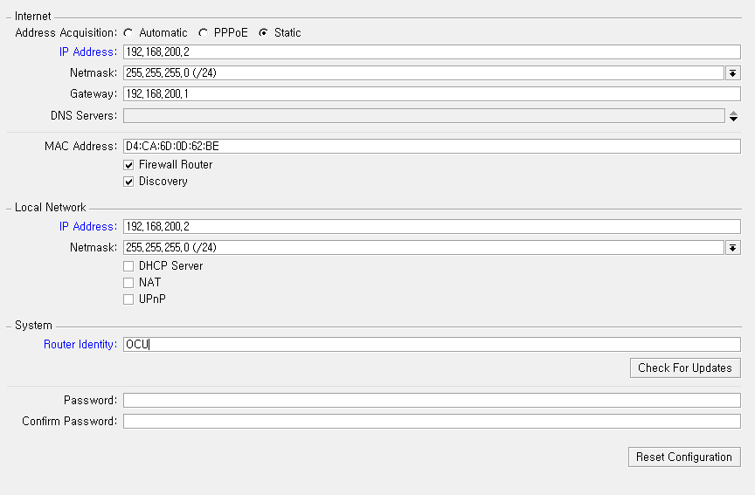
- In the ‘Internet’ tap check ‘Static’.
- In the ‘Internet’ tap put ‘192.168.200.2’ in the ‘IP Address’
- In the ‘Internet’ tap put ‘192.168.200.1’ in the ‘Gateway’
- In the ‘Local Network’ tap put ‘192.168.200.2’ in the ‘IP Address’
- In the left you can check whether radios are interconnected.

- Cannot connect to radio using Winbox.
In this case you should reset the radio.
There’s reset button the bottom.

Click reset button using sharp stick before insert Ethernet cable.
Insert Ethernet cable while click the reset button.
First light will beep and start to blink.
After 8 seconds, stop clicking the reset button.
If you succeeded, now you can connect to the radio using ‘Winbox’ tool.
Default IP is ‘192.168.88.1’

